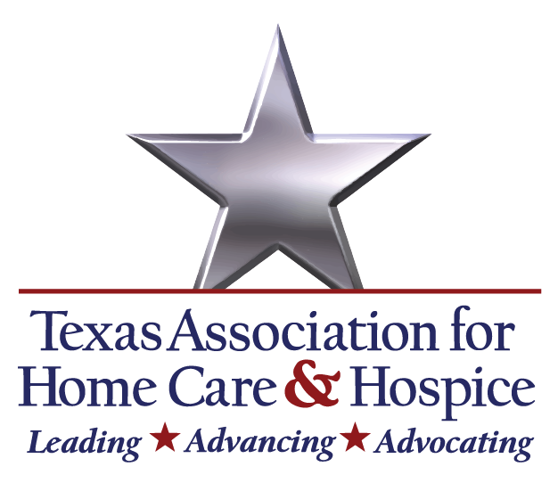

DC Fly-in 2025
Know Before you Go!

Thank you for participating in our DC Fly-in this year! We will put “Advocacy in Action” and advance our home health and hospice legislative priorities with Congress!
Listed below is an itinerary for your review. The first meeting you need to attend is the 6:30 pm Monday evening reception and briefing with our DC Lobby Firm (see details below).
TAHC&H DC Fly-in 2025 Itinerary at a Glance:

Monday, September 8th
- 6:30 pm: Reception and briefing with Akin Location: Akin Capitol Hill Office (700 Pennsylvania Ave. SE, Washington, DC)

Tuesday, September 9th
- 8:00 am – 5:30 pm: Legislative visits on Capitol Hill
*Note: You will receive a receive a detailed schedule of all Legislative visits at the Briefing on Monday, April 7. Fundraisers and PAC meetings will also be scheduled.

Wednesday, September 10th
- 8:00 am – 5:30 pm: Legislative Visits on Capitol Hill

Thursday, September 11th

Depart

TAHC&H Contact Information, call if you need assistance:
Rachel Hammon, TAHC&H (512) 565-8042 Hans Rickhoff, Akin (210) 683-2504
Kandis McClure, Akin (314) 604-1700 Audrey May Lucas, Akin (252) 514-5195
In preparation, please download the GroupMe app and sign up to the MOW group using this link for immediate updates during the visit.
Thank you for joining with home care and hospice colleagues from around the nation to lobby Congress. We look forward to seeing you in Washington, DC!

