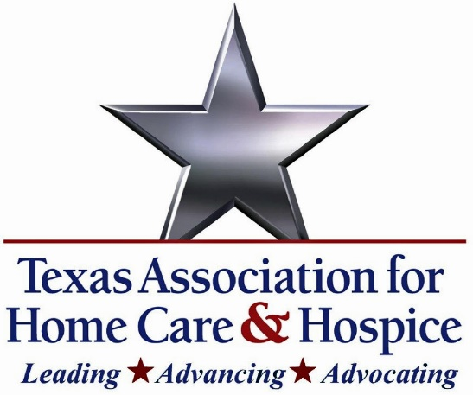
FOR IMMEDIATE RELEASE
May 20, 2026

Statement in Support of H.R. 8883, the Protecting Seniors and Stopping Fraudsters Act
[AUSTIN, TX] — The Texas Association for Home Care & Hospice (TAHC&H) strongly supports the Protecting Seniors and Stopping Fraudsters Act (H.R. 8883), introduced by Congresswoman Beth Van Duyne (R-TX), which targets fraud in the Medicare hospice and home health benefits while preserving access to high-quality care for the seniors and families who depend on it.
"H.R. 8883 takes the right approach to a serious problem," said Rachel Hammon, Executive Director. "By concentrating new oversight where the risk is greatest — newly enrolled providers, providers in known fraud hotspots, and providers exhibiting aberrant billing or discharge patterns — Congresswoman Van Duyne's bill goes after the bad actors who exploit vulnerable patients and drain the Medicare Trust Fund, without piling unnecessary burden on the mission-driven hospices and home health agencies delivering compassionate, quality care every day."
The legislation increases survey frequency for high-risk hospice and home health providers, strengthens enrollment screening in areas at extreme risk of fraud, raises the penalty for providers that fail to submit quality data, enhances federal oversight of accreditation organizations, and ensures Medicare beneficiaries receive clear written notice when they elect the hospice benefit. It also dedicates approximately $100 million to additional CMS surveys aimed at rooting out fraudulent operators.
TAHC&H thanks Congresswoman Van Duyne for her leadership on this critical issue and urges swift action on H.R. 8883.
# # #
About the Texas Association for Home Care & Hospice (TAHC&H):
##TAHC&H has championed the collective interests of Texas home care and hospice agencies, organizations, and individual professionals since its founding in 1969. Its mission, to advocate for ethical practices, quality, and economic viability of licensed providers in Texas, joins together member organizations and individuals in a shared commitment to every citizen in need of quality, affordable in-home services. CONTACT: Rachel Hammon (512) 338-9293 rachel@tahch.org

