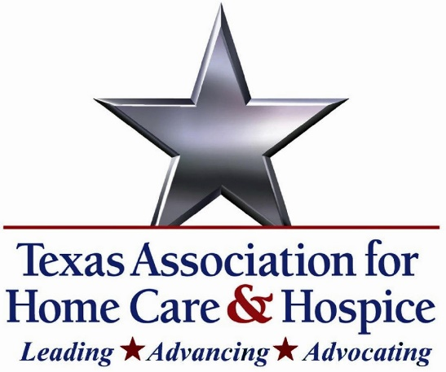

**Texas Association for Home Care & Hospice Applauds Introduction of the Prompt and Fair Pay Act**

**Austin, TX** — The Texas Association for Home Care & Hospice (TAHC&H) strongly supports the bipartisan **Prompt and Fair Pay Act (H.R. 4559)**, introduced by Representatives Lloyd Doggett (D-TX) and Greg Murphy, M.D. (R-NC). This legislation represents a critical step toward restoring fairness, transparency, and sustainability in the Medicare Advantage (MA) program.

Across Texas, home health and hospice providers are facing mounting challenges under MA plans—challenges that threaten both the viability of provider organizations and the timely delivery of care to vulnerable patients. Inadequate reimbursement rates, prolonged payment delays, and opaque administrative processes have created an unsustainable environment for those delivering essential, in-home services.

“For too long, home health providers have been forced to navigate a broken reimbursement system that delays care, burdens clinicians with excessive red tape, and underpays for essential services,” said Rachel Hammon, Executive Director of the Texas Association for Home Care & Hospice. “This bipartisan legislation is a vital step toward restoring fairness, transparency, and financial stability—ensuring that patients can continue to access high-quality care in their homes and communities.”

TAHC&H commends Representatives Doggett and Murphy for their leadership and urges Congress to advance this legislation without delay. As MA enrollment continues to grow, so too must the safeguards that protect patients, providers, and access to high-quality home care for Medicare beneficiaries.

##TAHC&H has championed the collective interests of Texas home care and hospice agencies, organizations, and individual professionals since its founding in 1969. Its mission, to advocate for ethical practices, quality, and economic viability of licensed providers in Texas, joins together member organizations and individuals in a shared commitment to every citizen in need of quality, affordable in-home services.

CONTACT: Rachel Hammon (512) 338-9293 🞟 rachel@tahch.org